 |  | ASSIGNMENT -4
 | Date |  | 21 October 2022
 | Team ID |  | PNT2022TMID07290
 | Student Name |  | Ramya.A
 | Roll number |  | 711519BCS046

1.Pull an Image from docker hub and run it in docker playground.

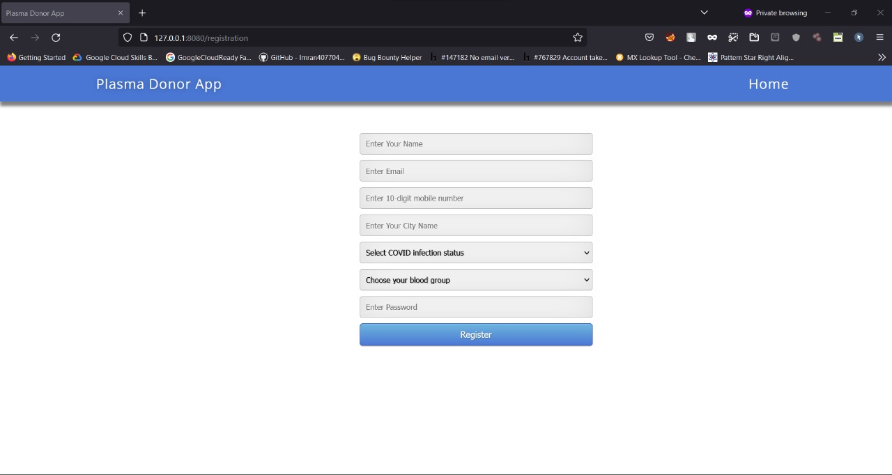

2. Create a docker file for the jobportal application and deploy it in Docker desktop application.

Dockerfile:

FROM python:3.6
WORKDIR /app
ADD . /app
COPY requirements.txt /app

RUN python3 -m pip install -r requirements.txt

RUN python3 -m pip install ibm_db

EXPOSE 5000

CMD ["python","app.py"]

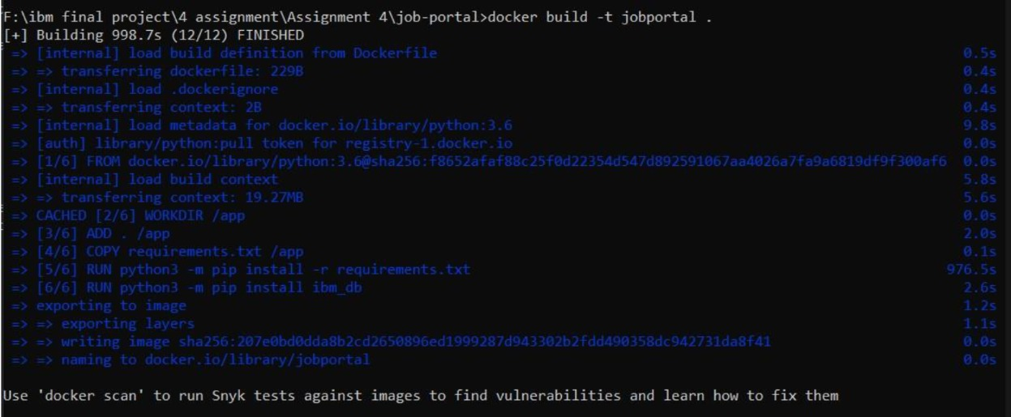

3. Create a IBM container registry and deploy helloworld app or jobportalapp.

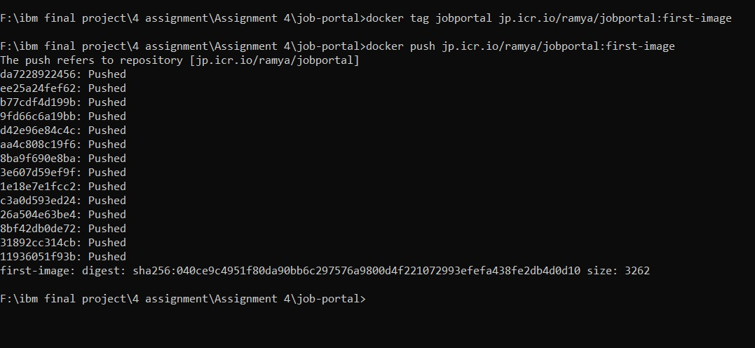

- Create a Kubernetes cluster in IBM cloud and deploy helloworld image or jobportal image and also expose the same app to run in nodeport.

